**CITY UNIVERSITY OF HONG KONG**

Course Code & Title: **GE2318**

**Complexity in Science and Engineering**

Session: Semester B 2023/24

This is a **closed-book** Test on Wednesday April 17, 2024

You have **1 Hour (1:30 - 2:30pm)**

**\* Student Name: ______________________**

**\* Student ID: _________________________**

Answer **all** questions.

**Directly write/draw on this hard copy of the test paper.**

Answering this exam paper implies your acknowledgment of the **Pledge** for following the **Rules on Academic Honesty**:

“I pledge that the answers in this examination are my own and that I will not seek or obtain an unfair advantage in producing these answers. Specifically,

1. I will not plagiarize (copy without citation) from any source;
2. I will not communicate or attempt to communicate with any other person during the examination; neither will I give or attempt to give assistance to another student taking the examination; and
3. I will use only approved devices (e.g., calculators) and/or approved device models.
4. I understand that any act of academic dishonesty can lead to disciplinary action.”

**Directly write/draw on this hard copy of the test papers and then return it**

**Question 1 [40 Marks]** (Chaos)

**Q-1.1 [10 Marks]** Answer the following **T**rue or **F**alse questions [2 marks each]

(1) A signal is chaotic if it is sensitive to initial conditions.

**Answer:** True or False

(2) If a signal is not divergent and not convergent then it is chaotic.

**Answer:** True or False

(3) If a signal is long-term unpredictable then it is chaotic.

**Answer:** True or False

(4) If a signal is a fractal then it is chaotic.

**Answer:** True or False

(5) If a signal is chaotic then it is a fractal.

**Answer:** True or False

**Q-1.2 [10 Marks]** Answer the following questions:

(1) [2 marks] In the lectures on chaos, CNN means _______________________

or _________________________

(2) [8 marks] Consider the following signals: **a. b. c. d. e. f. g.**

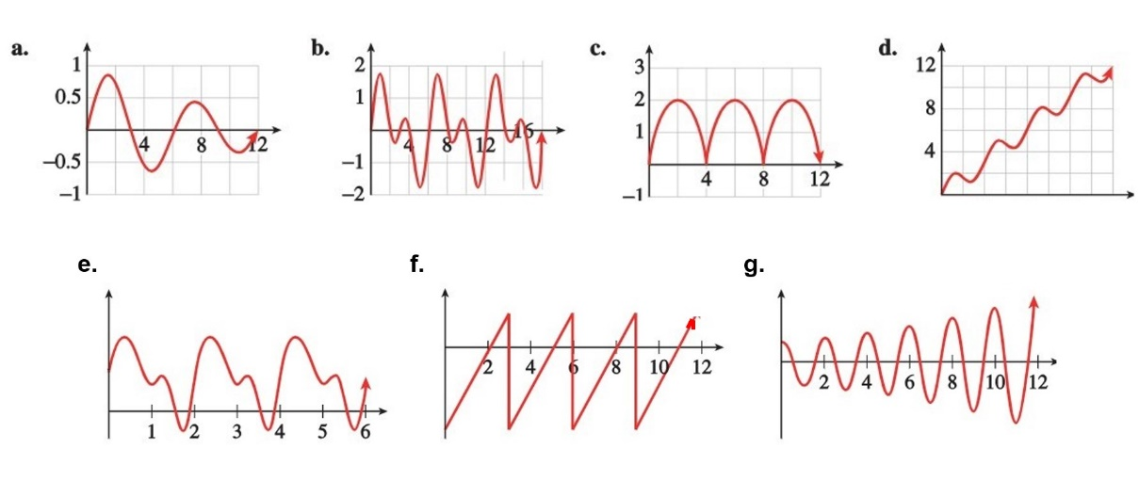

From their moving trends, identify which is (are):

(i) convergent signal(s): ___________

(ii) divergent signal(s): ____________

(iii) periodic signal(s): ____________

(iv) chaotic signal(s): ____________

**Q-1.3 [10 Marks]** Answer the following questions [2 marks each]

(1) The first chaotic system formulated is ____________ system

(2) The first chaotic circuit constructed is ____________ circuit

(3) A typical chaotic map with period-doubling bifurcations is _________ map

(4) In the 3-dimensional space, a moving signal hits 100 times on a Poincare section plane, leaving 100 points thereon. What kind of signal is it?

**Answer:**

(5) The most important property of chaos useful for liquid thorough stirring is:

______________________

**Q-1.4 [10 Marks]** (Chaos and Fractals)

(1) [2 marks] Is it possible to have a bounded region on the plane that has a finite area with an infinite boundary? Explain why you think so.

**Answer:**

(2) [4 marks] Can fractals be directly used for encryption and decryption applications? **Explain** why you think so.

**Answer:** __ Yes or No __ **Explain:**

(3) [4 marks] Chaotic robots are useful for de-mining, because:

**Answer:**

**Q2 [30 Marks]** (Fractals)

**Q-2.1 [10 Marks]** Answer the following **T**rue or **F**alse questions [2 marks each]:

(1) Some chaos has a fractal structure: ___ True or False ____

(2) Some fractals are chaotic: ___ True or False ____

(3) Fractals have non-integer dimensions: __ True or False __

(4) An object with fractal dimension 1.7 is more complex than an object with fractal dimension 1.3: __ True or False __

(5) A graph with self-similarity is a fractal: ___ True or False ____

**Q-2.2 [10 Marks]**

(1) [4 marks] Name **two** potential applications of fractals in engineering and

technology:

(1) _______________________ (2) ________________________

(2) [4 marks] Name **two** potential applications of fractals in arts and architectures:

(1) _______________________ (2) ________________________

(3) [2 marks] Name **one** potential application of fractals in biology: ___________

**Q-2.3 [10 Marks]**

(1) [5 marks] Is the following fractal chaotic? **Explain** why you think so.

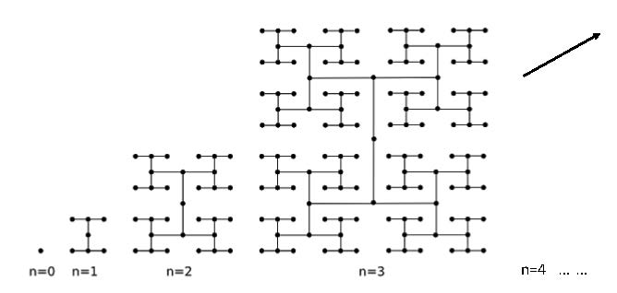

**Answer:** ___ Yes or No ___ **Explain:**

(2) [5 marks] Calculate the fractal dimension of the following Koch curves:

**Answer:**

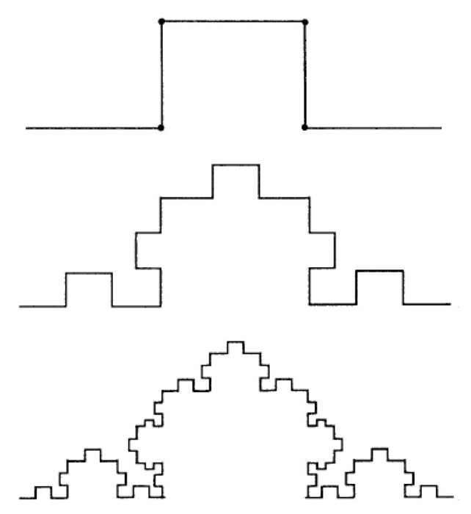

**Q-3 [30 Marks]** AI and Applications

**Q-3.1** [10 Marks] Answer the following **T**rue or **F**alse questions [2 marks each]:

(1) Machine learning is deep learning: ____ True or False ___

(2) Deep learning is machine learning: ____ True or False ___

(3) Machine learning cannot correct learning errors by itself: __ True or False __

(4) Deep learning can correct learning errors by itself: __ True or False __

(5) Deep learning has a certain level of human intelligence: __ True or False __

**Q-3.2** [10 marks] Answer the following questions:

(1) [3 marks] Every machine learning algorithm has **3** basic components:

(i) ____________________________

(ii) ____________________________

(iii) ___________________________

(2) [3 marks] Name **3** typical types of machine learning:

(i) ________________________________

(ii) ________________________________

(iii) ________________________________

(3) [4 marks] The main method for ANN learning/training is:

**Answer:** _________________________

**Q-3.3** [10 marks] Consider the following ANN. For $X1=1$ and $X2=2$, compute the

Output $Y$.

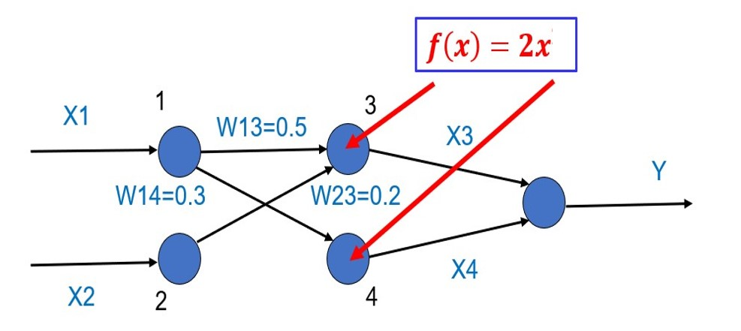

**Answer: $Y=$**

**--- Do not write on this page ---**

**Scores**

|  |  |  |
| --- | --- | --- |
| **Q-1.1** | 10 |  |
| **Q-1.2** | 10 |  |
| **Q-1.3** | 10 |  |
| **Q-1.4** | 10 |  |
|  |  |  |
| **Q-2.1** | 10 |  |
| **Q-2.2** | 10 |  |
| **Q-2.3** | 10 |  |
|  |  |  |
| **Q-3.1** | 10 |  |
| **Q-3.2** | 10 |  |
| **Q-3.3** | 10 |  |
|  |  |  |
| **Total** | **100** |  |